

**Social Media Campaign & Metrics**

**Multimedia University**

**Cyberjaya**

**Submitted to**

**Ms. TS. DR. GOH HUI NGO**

**Lecturer**

**Multimedia University, Cyberjaya**

**Prepared by**

|  |  |  |
| --- | --- | --- |
| **Name** | **Student ID** | **Group** |
| **Ong Pei Yong** | **1171100655** | **TC1V** |
| **Ng Zhen Xiong** | **1181302692** | **TC1V** |
| **Arpita Bhattacharijee** | **1171301208** | **TC1V** |

**Date of Submission: 3 October 202****1**

**Table of Contents**

Introduction 3

Huawei Mobile 3

Huawei current Social Media Campaign 7

Samsung 8

Samsung current Social Media Campaign 12

Dashboard Implementation and Metric used for analysing 14

References 17

# Introduction

A social media campaign is a marketing design to reinforce the information or emotions towards a service, product, activities, and overall brand through any social media platform.

Nowadays, Social Media Campaign is a booster for marketing efforts, in other words, it can be explained as a consistent bunch of energy that pays off in a major boost to the brand’s popularity, reputation, sales, and awareness. Social Media Campaigns contain different types of coordinated activities which target gaining a specific goal over a set period of time, where the outcome can be measured and tracked. It helps to find the insight, strategy in product service.

Our chosen domain is Huawei Mobile and Samsung Mobile. We analysed the data for the last one month data which is from 1st September until 30 September.  The most suitable campaign and their strategy for these domains are explained below:

# Huawei Mobile

We used word cloud to demonstrate the visualization. Word cloud is a convenient and quick visualization option for highlighting the frequency of the most prominent keywords within the source text data. It also helps to provide quick insight and conversation ideas.

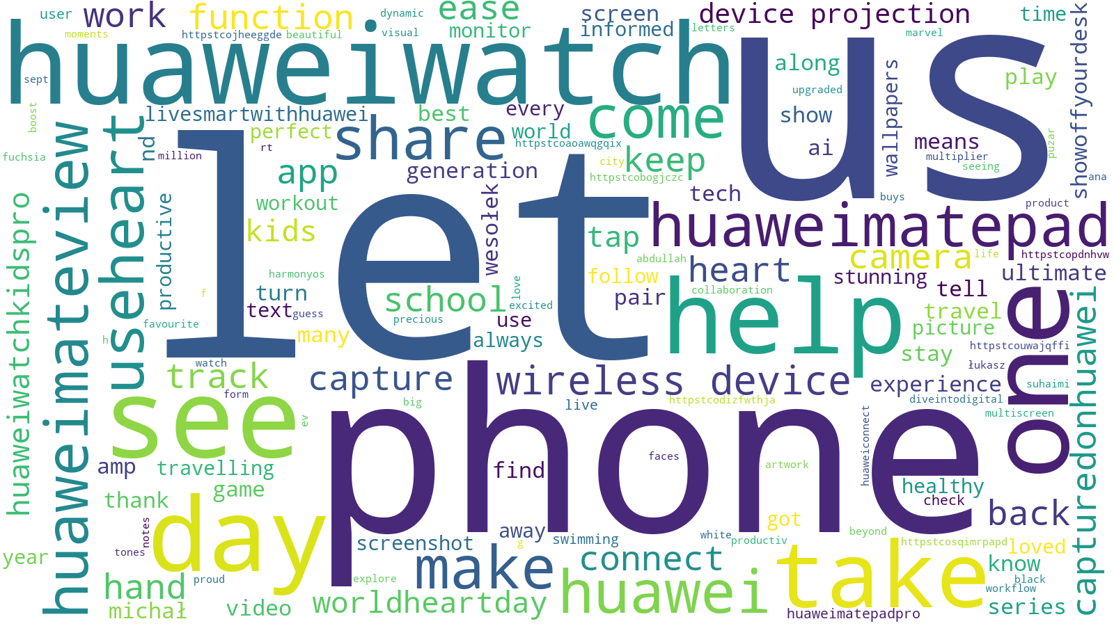

Figure 1 :Word Cloud of Huawei data

In figure 1, we can see some bold words: “huaweiwatch”, “phone”, “huaweimateview”, “worldheartday”, “huaweimatepad”, “camera” which represent the most prominent or used words in tweets. It can be observed that all these words are interrelated. Here, the joined words are used as the hashtags. Few statements are made from this word cloud:

* This cloud is presenting the feature of the phone using sentimental words which are: “camera stunning”, “wireless”, “productive” and “perfect”.
* Some activities are mentioned: “workout”, “traveling”, “swimming”, which are very inspiring to the audiences and thus can help to draw the attention
* The most used hashtags are “huaweimatepad”, “huaweimateview”, “huaweiwatch” which can be a possible campaign that companies are running.

Word cloud provides a quick view but for deeper analysis sometimes word cloud is not sufficient itself to reach the conclusion. For a better analysis, we extract hashtags for the tweets. Nowadays most of the business are using hashtag based campaign since hashtag is very helpful to attract new customers, generate the engagement and get followers to retweet or post about the hashtag (ThriveHive, 2015). This is why we decided to use the hashtag entity comparing with other metrics to keep track of running campaigns.

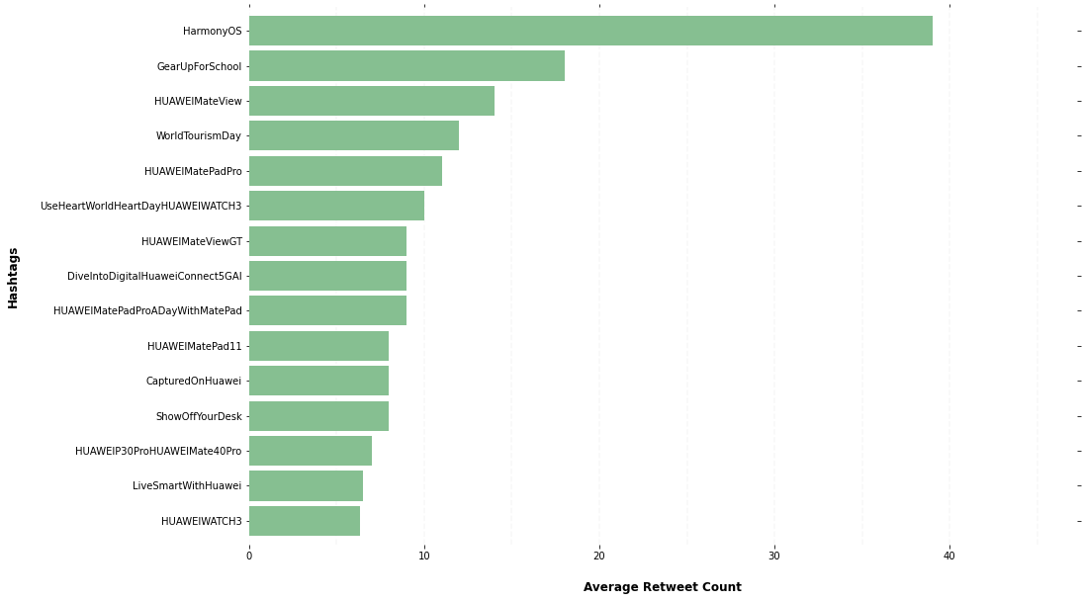

Figure 2 : Average Retweet Count of hashtags of Huawei

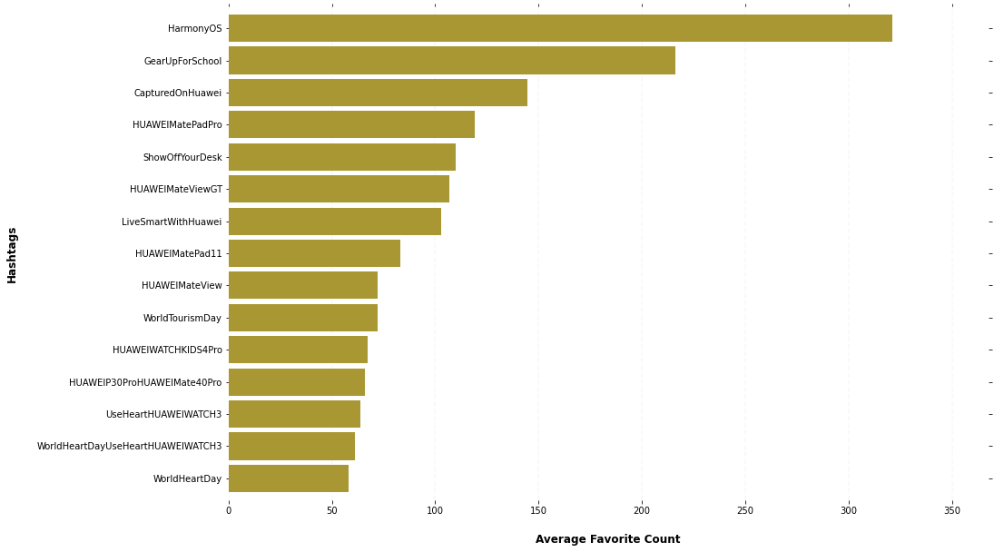

Figure 3 : Average Favorite Count of hashtags of Huawei

Figure 2 and 3 show the most average retweet and favourite count of used tweets by descending order which used hashtags. Both figures show the top hashtags which are “HarmonyOs”, “GearUpForSchool”.

HarmonyOs is Huawei’s proposed next-generation based operating system that brings a lot of new features between smart devices (Wikipedia, 2019). This hashtag shows a product promotion-based campaign that hit the most retweet count.

‘GearUpfornewschool’, ‘ShowoffourDesk’ are activity-based campaigns where it asked the followers especially the young ones to show up their e-learning setup. Giving a task to the follower can be a fun activity that also helps to reach for more engagement.

These analytics show that campaigns which is related to an innovative feature in products or showcase or task given to the followers are more entertained among the followers. Therefore, such a campaign is suitable for Huawei’s social media marketing.

Discovering the best day to tweet a post is an important key point for an effective social media campaign strategy (Patel, 2021). This is why we plot a graph to see the behaviour change of Retweet count and Favourite count over time for hashtags tweets. It shows, there’s a peek in count on 13,20,22,27 September. According to the calendar, these days are mostly between Wednesday and Friday. On the other hand, the count was very low on 2, 9, 16, 23 September and the interesting fact is all these days fall on weekends. Therefore, we can conclude running a campaign on weekdays may potentially grow more reach.

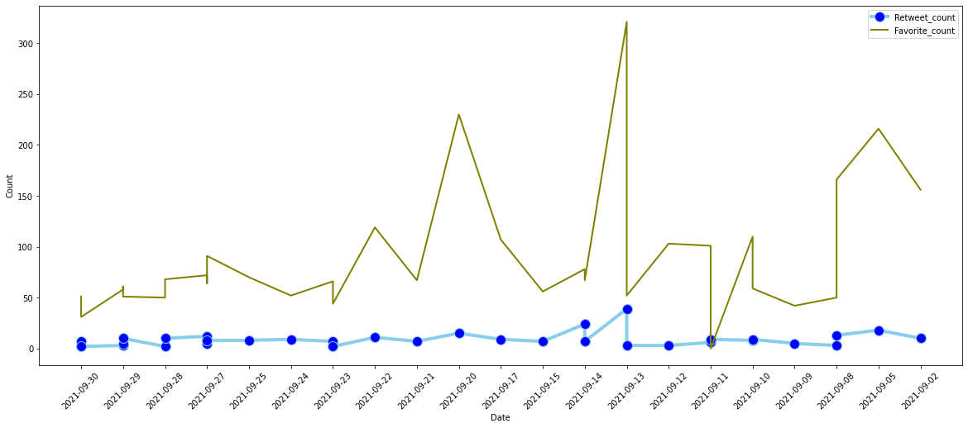

Figure 4 : Huawei Retweet and Favourite count over time

Social Media Marketing agencies or communities play a very important role in giving businesses a chance to follow their consumer’s activities or potential buyers. This also helps the business to know their target, likes, interest so that they can create a better marketing strategy to attach such customers. To extract this information we extract the source data of tweets which tells from where or through which platform the tweets are posted.

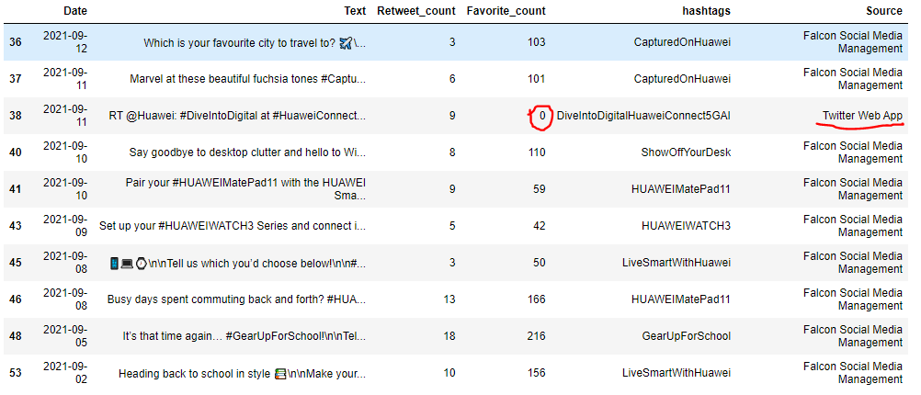

Table 1 : Huawei Data Frame

Table 1, shows that every tweet with hashtags that are posted through Falcon Social media managers has a great count for the retweet and also favourite counts. Falcon is a social media marketing agency and customer experience management. It helps by providing tools for social engagement, analytics, keeping track of the social media channels, and manages the customer data. On the other hand, as marked in red, where tweets are posted using tweeter web app have zero favourite counts and less retweet count. It can be concluded that posting tweets through a marketing agency helps to grow more engagement.

## Huawei current Social Media Campaign

To analysis the recent social media campaign we set the extracted timeline from “2021-09-24” until ”2021-09-30” which provides the last 1 week data.

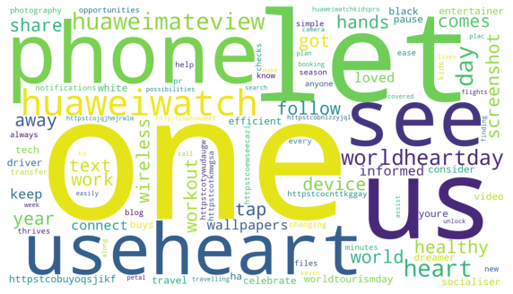

Figure 5 : Word cloud for recent Social media campaign

We plot a word cloud which is shown in figure 5 to get a quick idea of the recently posted tweets. From here, we can see the popular words are “huaweiWatch”, ”wordheartDay”, ”useheart”, ”phone”. Since we did not get much information from this cloud, we go for hashtags analysis for a better understanding of the recent trend in campaigns.

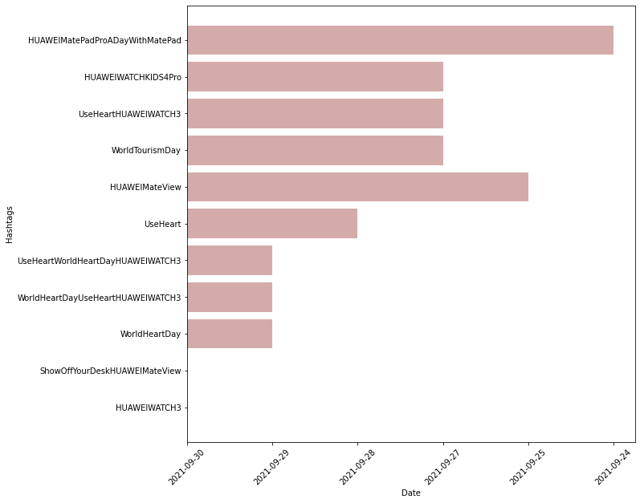

Figure 6 : Huawei recent Date of hashtags

Figure 6, shows the most recently used hashtags are HUAWEIMATCH3, Huaweimateview, and WordheartDay HUAWEIWATCH3, useheartwordday, useheart. In brief, the recent ongoing campaign is targeted at the popular hashtags trend and created hype on their new product Huaweimatch3. This product can store health information, maintain daily routine and help to manage a heart-healthy life. From the date data, we observed that 29th September is ‘world heart-day’. So this can be a possible statement that Huawei used this heart day trend to promote their new product. Looking for popular trends and hashtags plays an important role in social media campaigns. It illustrates that everyone will be able to see how on-point the product and the brand are while they are showcasing their brand personality. So overall, it is concluded that their latest campaign is related to health awareness by promoting the importance of healthy-life activities.

# Samsung

We choose Samsung as a competitor to Huawei. To examine the best campaign, it’s very necessary to analyse the other competitor’s business marketing to know the behaviour and change within the strategy.

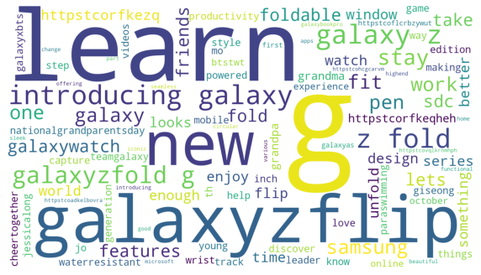

Figure 7 : Word Cloud of Samsung data

The word cloud for Samsung data for the entire of September is shown in Figure 7. The most prominent words are ‘galaxyzflip’, ’introducing galaxy’, ’fold’, ’waterresistant, ’galaxybts’. Analysing these words, we can assume, Samsung launched their new product where they mostly talk about the product features. To know further we plot the hashtag trend visualization with the measuring metrics: retweet count, favourite count shown in Figure 8 and Figure 9

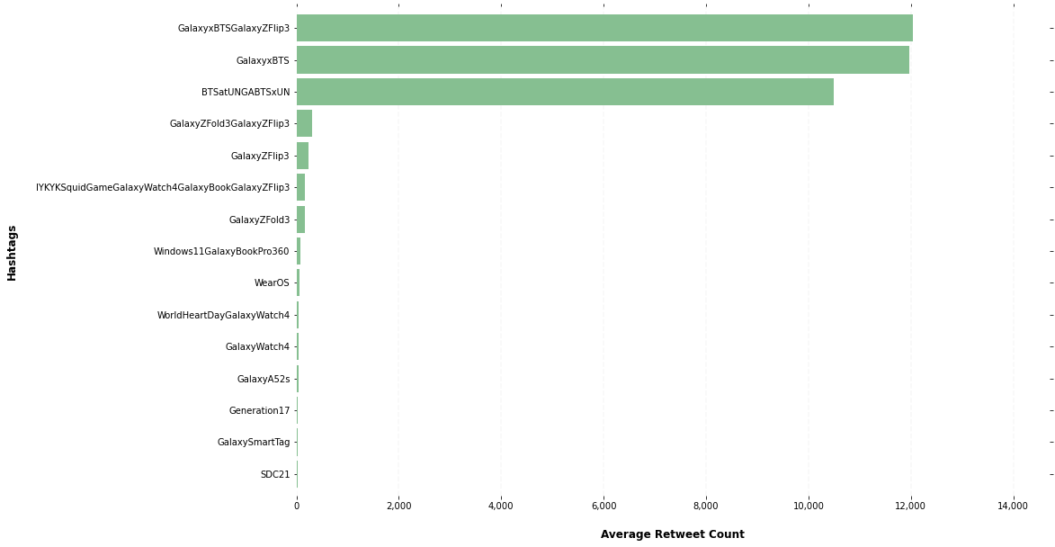

Figure 8 : Average Retweet Count of hashtags of Samsung

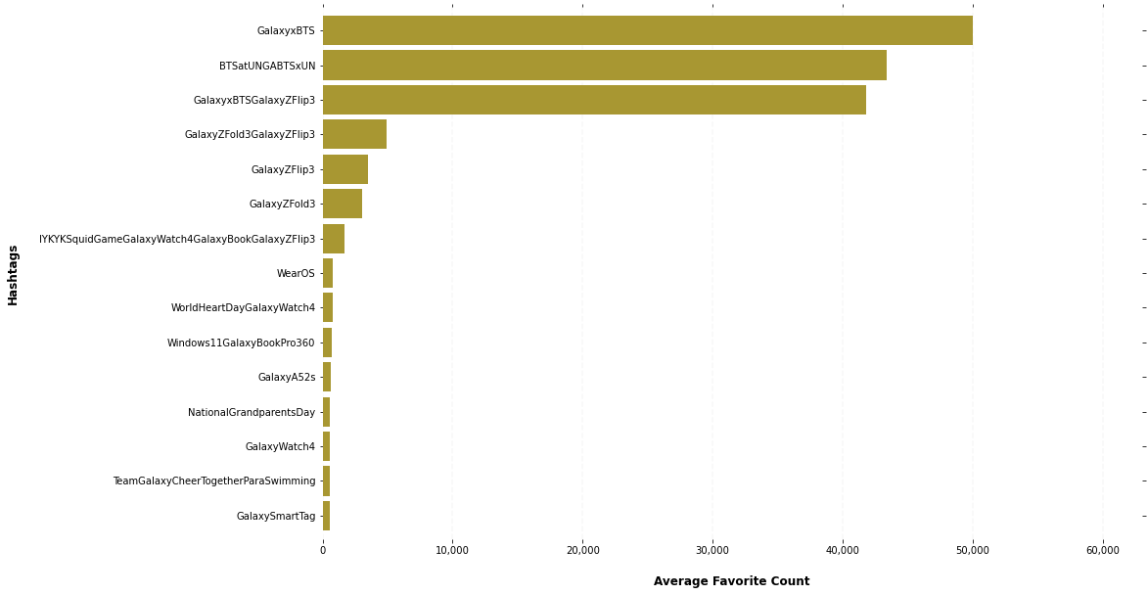

Figure 9 : Average Favourite Count of hashtags of Samsung

Figure 8 and figure 9 shows that the top 3 hashtag trends are ‘GalaxyBTSGalaxyZFlip3’, ’GalaxyBTS’, ’BTSatUNGBTSxUN’ with respect to the most retweet count and favourite count. The common fact in between all of these hashtags is, they are highlighting the hashtags adding the BTS tag. BTS is worldwide famous for its music. They have joined Samsung as global ambassador (Chan, 2021). This is one of those social media campaigns where the brand makes a partnership with an influencer. It is also known as the brand ambassador program. A brand ambassador program plays a partnership relationship between brand and influencer in order to improve brand awareness and drive sales. Indeed, the influencer becomes the main tag for the brand and they use their platform to promote a product or service. Thus, it helps to expand both the influencer and brand’s audiences. This type of exposure is what successful partnerships strive for. We see this partnership reflection in our measuring metric. Therefore, we can conclude that ‘Partnership with global ambassador’ is suitable for Samsung as it helped to grow more reach to the audiences.

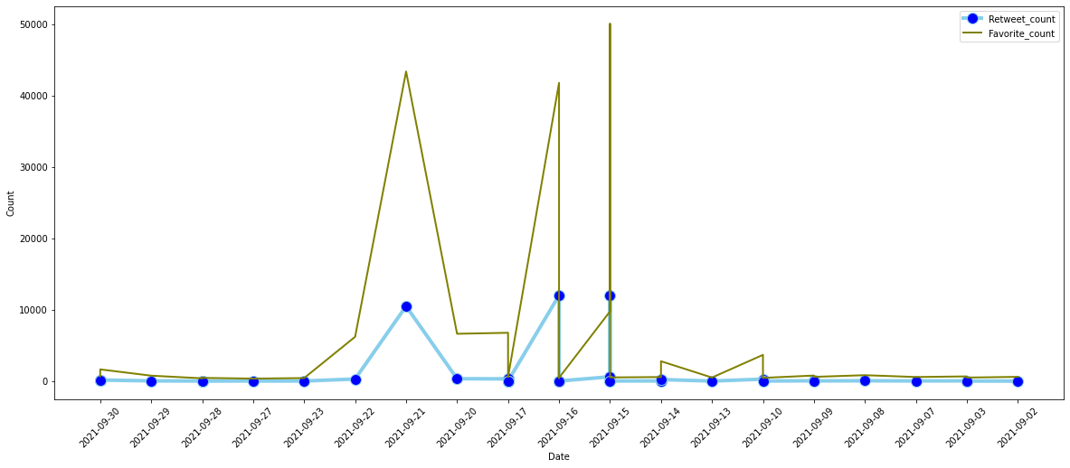

Figure 10 : Samsung Retweet and Favourite count over time

Figure 10 shows the count with respect to retweet count and favourite count over time. We can some peak value at 21, 15(weekdays) September and peek down at 16, 17 September which is the weekend day of the month.  Lead to the conclusion that, running a campaign on weekdays have much reach, effective and can be considered a good strategy than running a campaign on weekend.

We also wanted to say, in case there any effect of used platform/source on the reach of tweets and therefore, we extract the source information where we try to tally the data with a retweet and favourite count. Table 2 denotes that using the source: “Twitter media studio” very effective effect on the engagement metrics than “Twitter web app”. Basically twitter media studio platform is to measure, manage and monetize uploaded contents that tell a story using videos or images or gifs, overall using visual data which also means that content with videos or images helps to expand the reach to the audiences.

## Samsung current Social Media Campaign

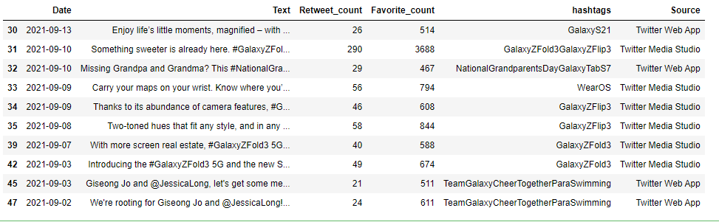

Table 2: Samsung Data Frame

Current Social Media campaign: To have a quick impression on recent tweets in Samsung, we plot a word cloud.

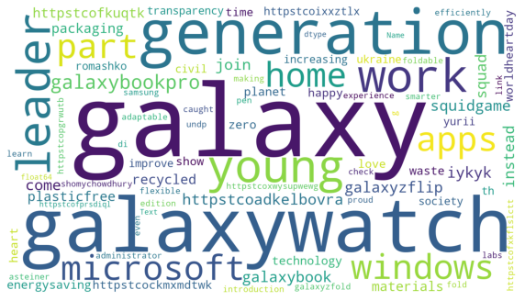

Figure 11 : Word cloud of recent Social media campaign of Samsung

From figure 11, it can be perceived that here the most prominent words are “generation”, “galaxywatch”, “Microsoft”, “leader”. Apparently, it can be assumed that they are running some new campaigns. We also analysed recent hashtags trends to keep track of the latest social media campaign, where the data period was from the last week of September.

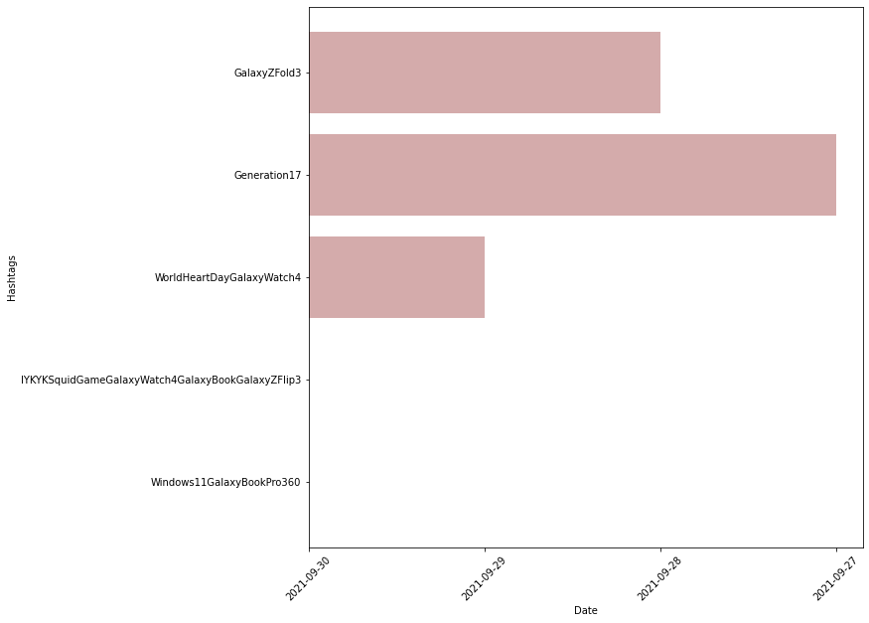

Figure 12 : Huawei recent Date of hashtags

Figure 12 shows the current social media campaign over time. Though our data is collected for the last week of September, some days are missing because no hashtag trends were run on those days. The most recent hashtag trend is “Windows11GalaxyBookPro360” which starts trending on 30th September. The message they are spreading through this campaign is their new product Galaxy Book Pro 360 5g which will not only support connectivity but will also become the first Samsung laptop to ship with windows 11 (Jones, 2021). We can see the hype in this campaign which is very innovative and has never been done before. This hashtag also includes “windows11” which is a branded tag. This hashtag can also attract the audience from the windows fan base and hence more reach to the audiences. Overall, this leads to the conclusion that Samsung is currently implementing a branding hashtag campaign.

# Dashboard Implementation and Metric used for analysing

We used 4 types of metrics to monitor and measured both company in term of non-financial and financial.

Daily increase of followers is measured because new followers mean that audiences think your profile is important or interesting enough to watch and regularly get your content in their feeds. This is a useful metric for brand awareness and growing your audience. Conversely, if the number drops, you might need to investigate further to see what the causes were.

Daily number of tweets is measured because we can see how active is the page or the company that tweets their content and see how much engagement or new followers did they get per tweet.

Daily increase of retweet count is measured because retweets can help companies to promote their tweet more further and expand their marketing to reach different types of customers and attract new customers to their company or pages.

Daily increase of favourite count is measured because it at least can show that the customer interacts with the post which can be an engagement matrix to be monitored.

Using the script that we created, we manage to scrape the data of Samsung and Huawei from their Twitter account. Data we collected are Number of Tweets, Number of Followers, Number of Friends, Total Retweet Count, Total Favourite Count, Average Retweet Count, Average Favourite Count and Date. Metrics that we are measuring are the number of daily increases of followers, tweets posted, favourites and retweets for both brands.

So there will be 4 graphs to show the increment of the data for both brands. For the graph, we are using Matplotlib to plot it out and write some story telling based on the line graph. Steps are relatively easy, first we read data we collected from the .csv file and plot accordingly to followers, tweets posted, retweets and favourites. Do note that the data we scraped are the daily total, so to obtain the daily increase we will need to take the number of days after minus the number of days before. This can be archive in Python by a single line of code: datalist = [y-x for x,y in zip(datalist,datalist[1:])]

With the graph obtained, we will then create a dashboard using Streamlit and visualize all of the results for a better overview.

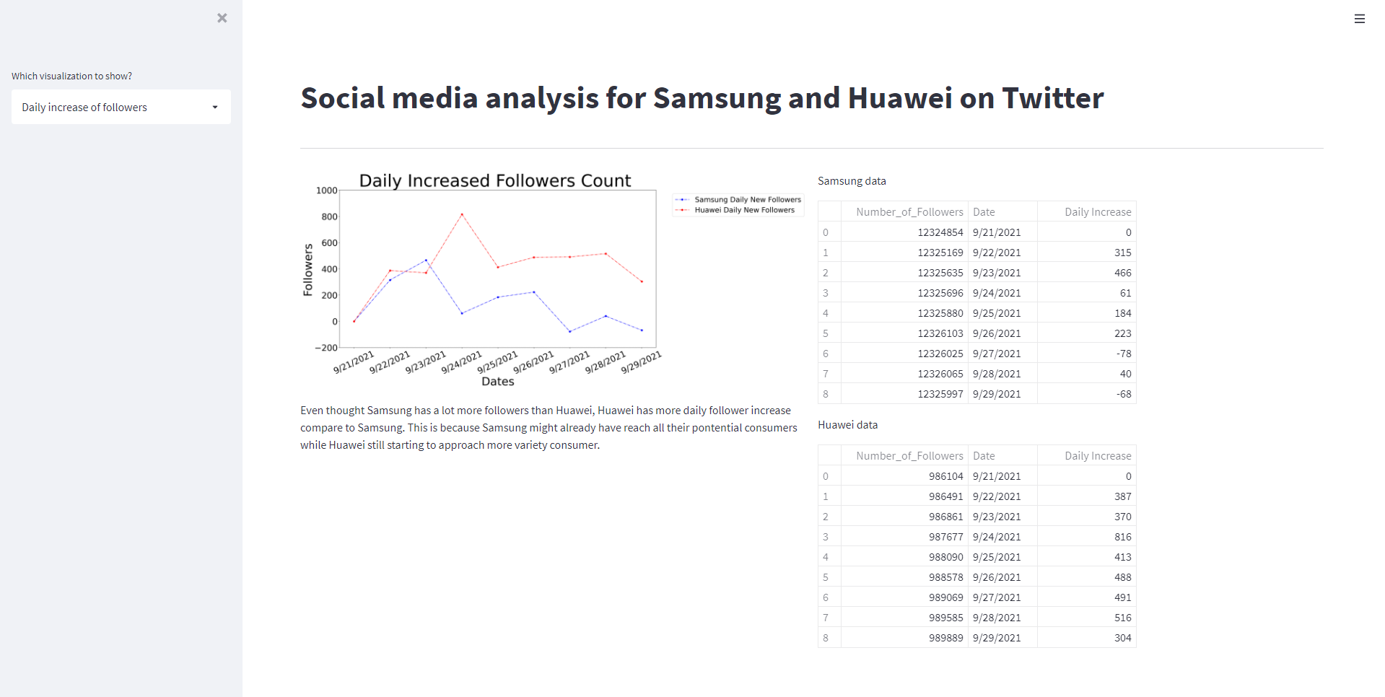

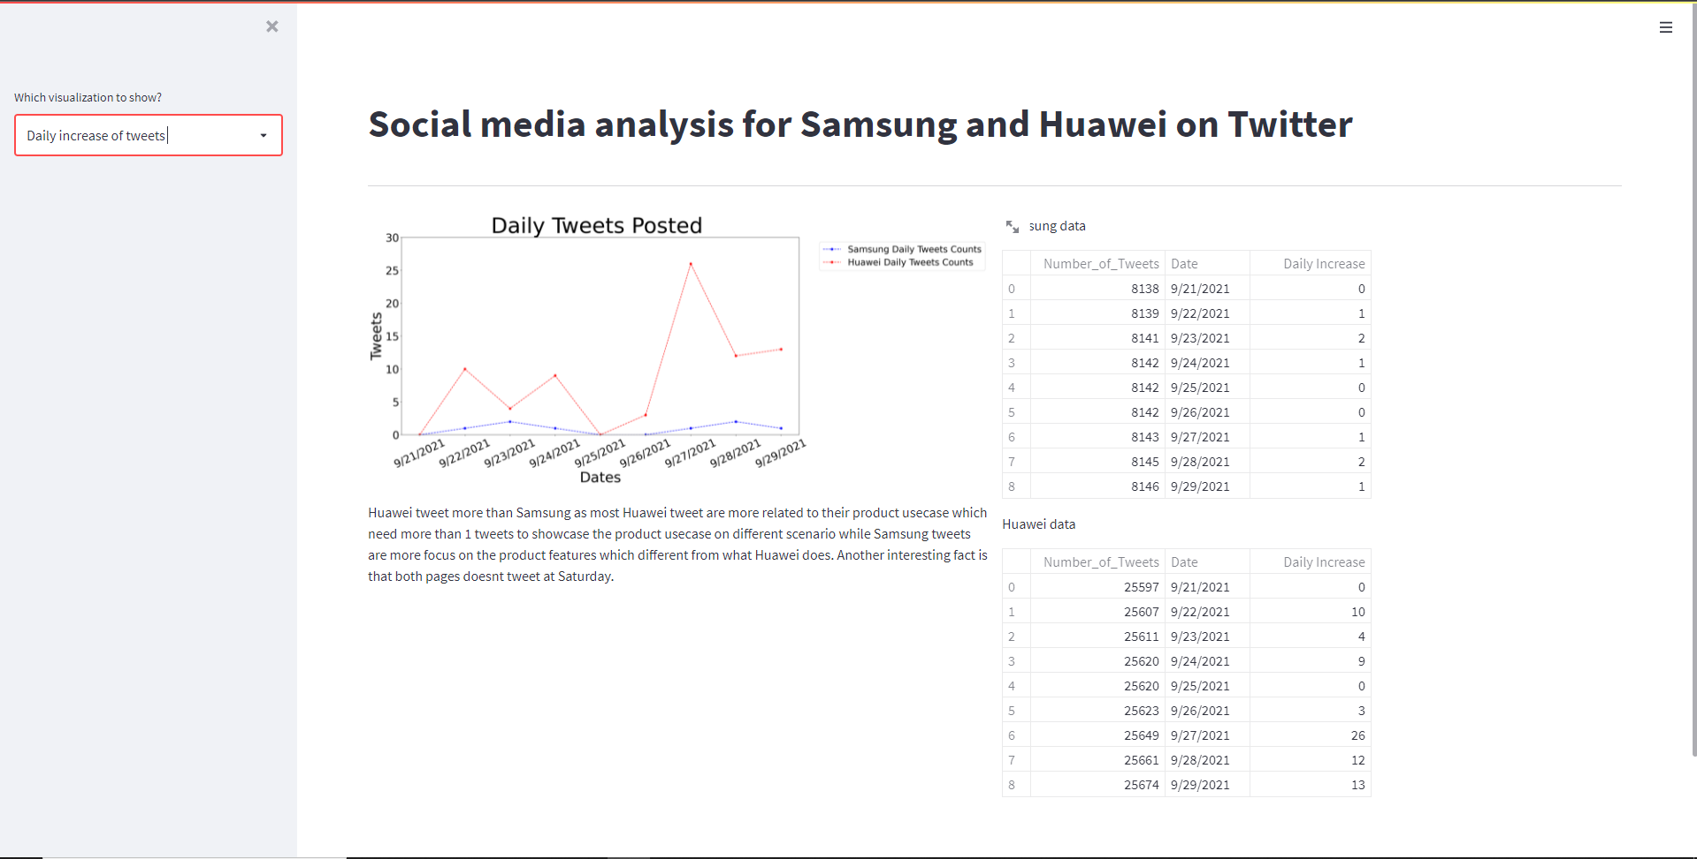

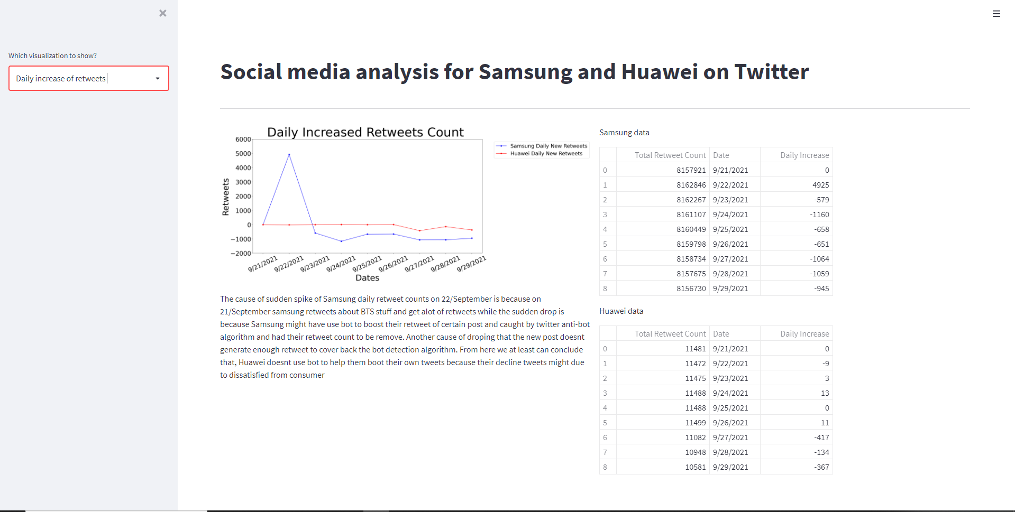

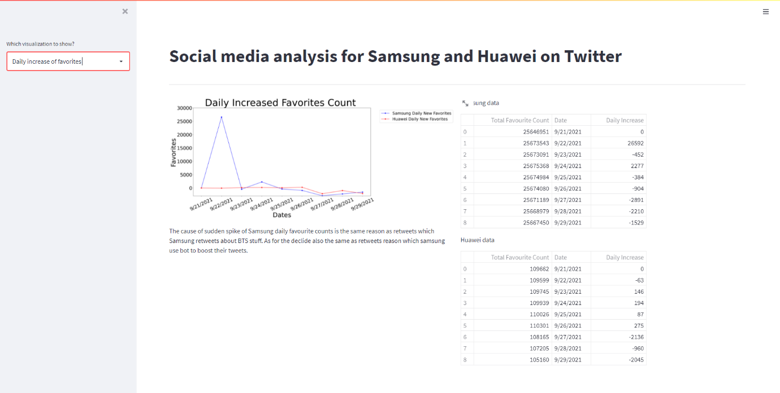

The dashboard can be simply run just by activating Anaconda Prompt and type in the command: streamlit run smc_dashboard.py .

# References

Chan, T. (2021, August 27). *Power of BTS Compels You: These BTS-Backed Phones Broke Pre-Order Records for Samsung.* From Rolling Stone: https://www.rollingstone.com/product-recommendations/electronics/bts-samsung-phone-galaxy-z-flip-fold-3-1218006/

Jones, R. (2021, September 22). *Samsung adds 5G and Windows 11 to the Galaxy Book Pro 360.* From Trusted Reviews: https://www.trustedreviews.com/news/samsung-adds-5g-and-windows-11-to-the-galaxy-book-pro-360-4169003

Patel, N. (2021, June 12). *Social Media Marketing: How to do it, Types, Tools & Tips.* From Neil Patel: https://neilpatel.com/what-is-social-media-marketing/

ThriveHive. (2015, June 25). *How to Use Hashtag Marketing to Grow Your Business .* From ThriveHive: https://thrivehive.com/how-to-use-hashtag-marketing-to-grow-your-business/

Wikipedia. (2019, May 20). *HarmonyOS.* From Wikipedia: https://en.wikipedia.org/wiki/HarmonyOS